# [Quantum Resistant](https://twitter.com/QRLedger) Ledger | TESTNET INSTALLATION GUIDE

**Running a Quantum Resistant Ledger node on a Raspberry Pi or Ubuntu Server:**

## Getting setup OS for Raspberry Pi:

1. **Download an ISO image for your Raspberry Pi and write it to your MicroSD card.**

<https://www.raspberrypi.org/downloads/raspbian/>

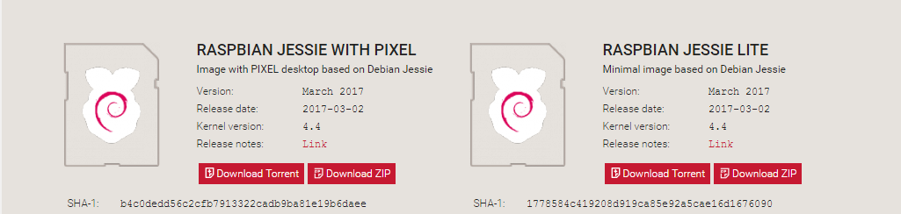

*You can also download Ubuntu server and configure remotely from putty:*

<https://www.ubuntu.com/download/server> 🡨 Ubuntu Server download

[Connecting from Windows to Ubuntu Server via SSH, using Putty.](https://www.youtube.com/watch?v=tiPZGba2qJg) 🡨 Tutorial

[PUTTY installation package](http://www.chiark.greenend.org.uk/~sgtatham/putty/latest.html) 🡨 Putty download link

1. **Power up your Raspberry Pi / Ubuntu Server.**

\*\*\*\*\*\*\*\*\*\*\*\*\*\*\*\*\*\*\*\*\*\*\*\*\*\*\*\*\*\*\*\*\*\*\*\*\*\*\*\*\*\*\*\*\*\*\*\*\*\*\*\*\*\*\*\*\*\*\*\*\*\*\*\*\*\*\*\*\*\*\*\*\*\*\*\*\*\*\*\*\*\*\*\*\**Tested OS versions: 2017-03-02-raspbian-jessie and 2016-11-25-raspbian-jessie*

*(these images come with pip, git and python 2.7 included)*

*Image building on windows can be done by using* [*Win32 Disk Imager*](https://sourceforge.net/projects/win32diskimager/) *or* [*Rufus*](http://filehippo.com/download_rufus/)

*************************************************************************************

1. **Downloading the necessary dependencies:**

*Open a terminal (crtl+alt+t) and type the following commands:*

sudo apt-get install python python-pip python-dev git build-essential

sudo apt-get install telnet

sudo pip install jsonpickle

sudo pip install leveldb

sudo pip install Twisted==16.0.0

sudo git clone <https://github.com/surg0r/QRL> \**(this will download the source code to /home/pi/QRL)*

1. **Running the node:**

*Open a terminal (crtl+alt+t) and type the following commands:*

cd QRL <--------------------*\*(Open the QRL folder)*

sudo python node.py *<--------------------*(Run the node.py script)*

*If you've set it up correctly, it should start to output the following: *

After the wallet is created it will start syncronizing the chain.

This might take a while, leave it running untill the chain is sync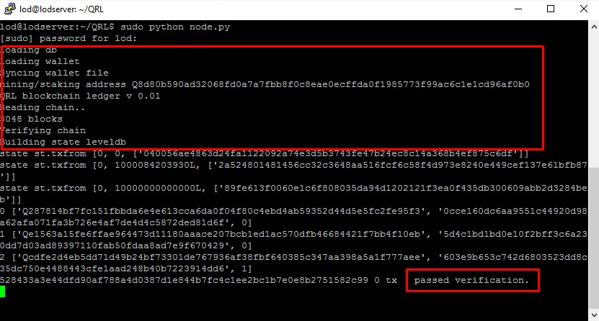

1. **Accessing the wallet:**

sudo python node.py *<-------------*(Run the node.py in one terminal)*

*Once it starts the synchronisation process, you can telnet into the node:*

telnet localhost 2000 *<---------*(Run this command in another terminal)*

*If you've set it up correctly, your second(wallet) terminal will look like this:*

